Winter Solstice Renewal

2023 Edition
honor . celebrate . grieve integrate . vision

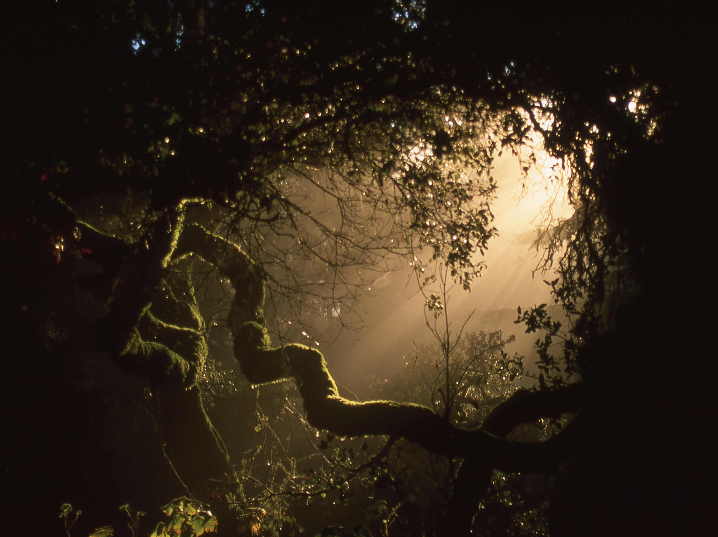
A conscious year-end reflection process to welcome back the light

Honoring the Arc
Reflection & Creation

As another year draws to a close, it's a pivotal time for introspection, aligning with the rhythm of the season, and dedicating ourselves to a meaningful reflection on the past year’s journey.

In the rush of daily urgencies, it's tempting to overlook such reflection. Yet, it's during these times that pausing to reflect becomes even more crucial.

Through reflection, we gain deeper insights, fostering a greater likelihood of honoring and integrating our experiences as we advance, both individually and collectively.

I've blended elements from various reflective practices into this exercise, structured around key questions:

- What were the prominent themes, learnings, milestones, and patterns of the past year, both personally and collectively?
- How have these elements shaped your life, learning, choices, and experiences?
- What aspects of the past year call for grieving, releasing, forgiving, composting, or integrating?
- What achievements and moments warrant celebration and recognition?
- What intentions are emerging for the coming year that align with your vision for yourself, your loved ones, your community, and the broader world?

This practice is designed to deepen learning and surface intentions for the upcoming year and beyond, starting our next orbit around the sun with a full appreciation of our journey and a clear direction forward.

Take your time with each question, allowing the process ample space to evolve. Initially, engage in solitude – perhaps during nature walks, beside a fire, through art, music, journaling, or recording your thoughts. Then, share your insights and discoveries with your close circle – partners, family, mentors, and allies, and eventually, with your wider community.

Create a sacred space in whatever way is authentic for you - using sage, incense, music, or candles, for example. Approach this process with patience, mindfulness, honesty, openness, and intention. Historically, this was a prolonged ceremonial practice during the darkest days of the year.

If you undertook a similar reflection last year, revisiting those notes can provide valuable insights into your evolution.

Enjoy exploring the elements of this practice that resonate most with you and feel free to share it with others who might find it beneficial.

As we weave our individual and collective visions, intentions, commitments, choices, and actions, we shape our shared future. Each section of this exercise offers guiding questions to explore; select those that resonate or create your own.

Share this practice with friends and family, as it can be a powerful exercise to undertake together during the holiday season.

Let’s honor the past year and use our learnings and growth to nurture the possibilities of the new year and beyond. Wishing you a fulfilling journey into the new beginnings. The light is on its way!

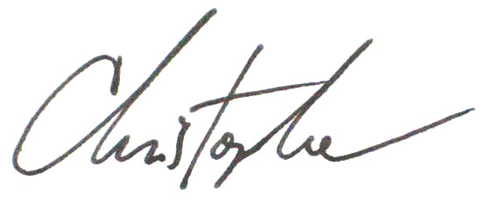
With care and encouragement,

PART 1

REVISITING THE BIGGER PATTERNS OF OUR LIVES:

MILESTONES: In my life (not just this year), what have been the stepping stones or milestones that have brought me in closer connection to myself, my vision, my purpose? What have been the most significant experiences that have shaped who I am today? If you haven’t done this before, take some time to track these big picture patterns over the years.

SYNCHRONICITY, NATURE CONNECTION, and the SACRED: When have I experienced intuition or synchronicity in my life? What kind of dreams or guidance have come to me, or have been recurring? What nature elements or creatures have I felt most connected to? What have they taught me or how have they influenced my life? What is (the) sacred to me, and how do I touch and engage this in my life?

MY GIFTS: What gifts/talents have I connected to in my life that I have either been told I embody or that I have felt within myself (or both)? What has been easeful around connecting to my gifts; what has been challenging? How have I cultivated my gifts throughout my life? What has gotten in the way?

OBSTACLES & CHALLENGES: What have been some patterns around the obstacles and challenges I have faced? These could be within myself (beliefs, mental models), behaviors and habits, traumas and hurts that impact your experience of yourself or in life, or other things that keep showing up in my life.

PART 2

HONORING THE MOVEMENTS OF 2023

What intentions did I set for 2023 (look over notes, journal, etc)? How did I hold these, especially given the many unexpected twists and turns of the year?

What are the accomplishments and milestones I want to celebrate from this past year?

What are some patterns, take-aways, and learnings from the above accomplishments that I want to harvest? How did I show up, and what can I honor in myself that made these movements possible?

What went really well, where was there ease and flow?

What was challenging? What obstacles did I encounter along the way? What worked well as I encountered them, what was challenging, and what have I learned?

What have been some magical moments in my year? What synchronicities can I remember? What were the circumstances? How did that feel? How am I carrying these now?

When have I really felt connected to the earth, to myself, to others, to my vision? What experiences stand out?

What has felt supportive and nurturing in times of ease, and in times of challenge?

What am I grateful for from the last year?

How have I been moved by local, national, and global events this year (climate change, war, politics, racial justice, fire, etc)? How have the more collective movements influenced my life and my path? What is rising in me around these happenings? How do my life and path interweave with the larger whole? What is being called forth in me?

Who are the people that have been influential this year and what gifts did they bring into my life? What did I learn from them? How will I honor these gifts?

What judgments do I carry about what I have experienced, have done or not done, or things that have happened this past year?

What do I need to grieve, let go of, or compost? (these could be emotions, material things, projects, relationships, patterns of thought or behaviors, habits, ways of being, judgments of self or others, etc…)

Who and/or what do I need to forgive? Make a list of things you want to forgive yourself for. Then make a list of things you want to forgive others for.

If there are some things or people I am not ready to let go or forgive - but want to - how will I arrive at the readiness to do so? What do I need to do, and what support do I need?

PART 3

LOOKING AHEAD:

Make a personal Life Wheel (include your own categories, such as family, health, service/work/career, home, spiritual path, creativity, community, etc…)

What am I called towards in the different aspects of my life… What do I want to create more of in my life this coming year, and where are my fertile edges? State some intentions for each life area.

What does resilience look and feel like to me, and how can I cultivate this experience in myself and in my community?

Specifically, how do I want to evolve how I am of service this year - with my friends, family, community, and in the world?

Overall, what qualities of being would support me in fulfilling my intentions in the above areas?

CREATIVE SCENES

If you want to go deep with this process of intention-setting, use some separate sheets of paper or your journal to develop Creative Scenes for each of your life areas. To do so, imagine… if you were to paint a picture of your life fully actualized to your heart’s calling - for each different element therein (family, health, service/work/career, home, spiritual path, creativity, community, etc…) - what would your life look like totally actualized?

If you would like an introduction to this practice, click HERE. If you are receiving a hard-copy of this process, you will have this introduction included in your booklet.

Some key goals and/or milestones I want to be able to celebrate in each area of my life wheel at the end of 2024 are…

Some specific commitments I want to make to help me reach these goals / milestones are…

In order to accomplish these things, how will I need to grow? What skills, competencies, and qualities do I feel inspired to develop and nurture in myself?

What will help me follow through on these commitments and goals, and move towards these intentions? What kind of support do I need?

PART 4

SHARING YOUR REFLECTIONS WITH OTHERS:

Remember to share your reflections and inner movements with others (human and non-human) in an intentional, ceremonial space. Celebrate, honor, let go, grieve, and release… You can add ritual to this releasing process… like burning notes in a fire, or literally composting them in the ground. Find ways to let energy and emotions move through you that may have been stored up over time… Find ways to do this somatically and in community where possible.

This makes space in your system in order to welcome in with curiosity, creativity, and wonder what wants to come forward this coming year. To embody this, you an even literally plant seeds of intention - yes, like in your garden. And you can share your visioning work, intentions, and commitments with others in your life, so these germinating seeds can be tended by community.

When ready, find some way to create completion and celebration around your process. Music and dancing, sharing food with those you can safely visit with, etc. - even over Zoom - all can help ground and integrate your process. Then revisit throughout the year as you are called.

---

I hope the process has been helpful and supportive and that you found ways to make it truly your own. I’d love to hear from you if you feel inspired to share about how it went for you.

Let me know if you have questions or need additional support. You can be in touch via my contact page.

Here’s to a healthy, resilient year.

Love,
